Day 2 Activities: Transitioning to Technical Planning
- Technical Requirement:
- Frontend Requirements:
The frontend is designed to deliver a seamless, user-friendly experience across all devices. Key requirements include:
  - User-friendly environment to browse data:
  - Responsive webpage
  - pages are
(Home , login , signup , contact , cart , billing , products) etc.
- Sanity CMS as Backend:
Sanity CMS is used as the backend system to manage and store the platform's data. Key requirements include:
Data Management:
  - Products: Manage product details like name, price, description, and stock availability.
  - Customers: Store customer profiles and contact information.
  - Orders: Maintain order records, including order status and payment details.
Schema Design:
  - Define schemas in Sanity CMS to align with the business objectives identified on Day 1.
  - Ensure the schemas efficiently support the marketplace's scalability and functionality.
- Third-Party API Integrations
To enhance functionality and provide essential services, integrate the following APIs:
  - Shipment Tracking API: Fetch and display real-time shipment updates for customers.
  - Payment Gateway API: Facilitate secure payment processing during the checkout process.
  - Additional Backend Services: Integrate other APIs as necessary to support features like tax calculation, discounts, or analytics.
  - Data Flow: Ensure the APIs provide accurate and relevant data for frontend interactions, including updates for order status, payment confirmations, and tracking information.
- Designing the System Architecture:
- System Architecture Overview
The system architecture consists of the following core components:
- Frontend (Next.js): Handles user interactions and displays dynamic content.
- Sanity CMS: Acts as the backend, managing product data, customer profiles, and order details.
- Third-Party APIs: Supports functionalities like shipment tracking and payment processing.
- Payment Gateway: Secures payment processing and ensures successful transactions.
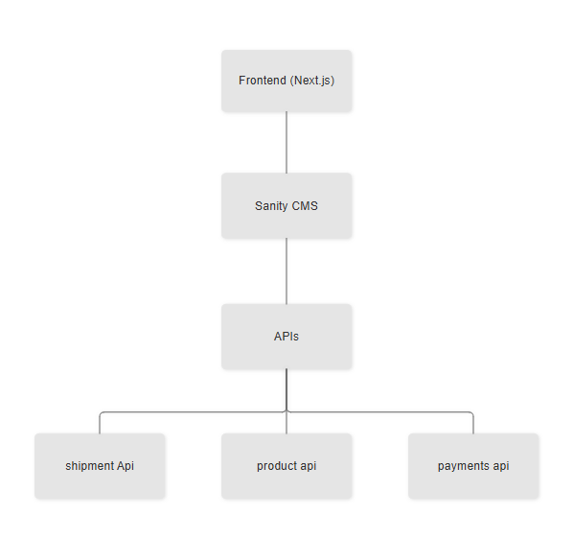

- User Registration:
User signs up -> Data is stored in Sanity -> Confirmation sent to the user.
- Product Browsing:
User views product categories -> Sanity API fetches data -> Products displayed on frontend.
- Order Placement:
User adds items to the cart -> Proceeds to checkout -> Order details saved in Sanity.
- Shipment Tracking:
Order status updates fetched via 3rd-party API -> Displayed to the user.

- Planning API Requirements:

Endpoint Name | Method | Description | Request Payload | Response Example
/products | GET | Fetch all the available products from Sanity. | None | { "id": 1, "name": "Product A", "price": 100, "stock": 20, "image": "product-a.jpg" }
/orders | POST | Create a new order in Sanity. | { "customerId": 123, "products": [{ "productId": 1, "quantity": 2 }], "paymentStatus": "Paid" } | { "orderId": 456, "status": "Success", "message": "Order created successfully." }
/shipment | GET | Track order status via a third-party API. | None | { "shipmentId": 789, "orderId": 456, "status": "In Transit", "expectedDelivery": "2025-01-20" }

- Sanity Schema Example:

{
"success": true,
"data": [
{
"productName": "Nike Air Force 1 Mid '07",
"category": "Men's Shoes",
"price": 10795,
"inventory": 20,
"colors": [
"White"
],
"status": "Just In",
"image": "https://template-03-api.vercel.app/products/1.png",
"description": "The Nike Air Force 1 Mid '07 delivers timeless style with premium leather and mid-cut design. Perfect for everyday wear, it provides exceptional comfort and durability. The iconic Air-Sole cushioning adds responsive support for long-lasting performance."
},
]
}

